Bahria University

Karachi Campus



**CQI REPORT**

(SOFTWARE CONSTRUCTION)

**“Smart Home Automation System”**

|  |  |
| --- | --- |
| Student Name | Enrollment |
| Rana Muzammil | **02-131222-012** |
| Mohsin Akhtar | **02-131222-005** |
| Mumeeb Niaz | **02-131222-122** |
| Zaeem Shafqat | **02-131222-028** |

**Submitted to: Engr. Muniba Humayun**

**1. Project Definition**

A Smart Home System integrates IoT devices and automation to allow homeowners to monitor, control, and automate their homes remotely. The system will include:

* Control over lights, fans, ACs, and other appliances.
* Security features like door sensors, motion detection, and camera monitoring.
* A mobile app interface.
* Voice assistant integration.
* Real-time status and alerts.
* Automation rules (e.g., turn on lights when motion is detected).

**Target Users:** Homeowners, renters, tech-savvy individuals, families.

**Stakeholders:** Users, developers, hardware manufacturers, security providers.

**2. Vision Statement**

*"Our goal is to deliver a smart automation experience that’s simple, intelligent, and secure — making everyday living easier, safer, and more efficient, all while being accessible from anywhere at any time."*

**3. Functional Requirements**

**Login and User Roles**

* Users should be able to create their own accounts and log in securely.
* Admin users should have more control and use extra login steps like verification codes.

**Connect and Set Up Devices**

* The system should find and add smart devices (like lights and cameras) automatically.
* It should also let users add devices manually using a control panel.

**Main Control Panel**

* A control center should be available on both phone and computer to see and control all devices.
* The system should work with voice tools like Alexa or Google Assistant.

**Automate Tasks and Set Schedules**

* Users should be able to set rules like “turn on hallway light when motion is detected.”
* They should also be able to set times to turn devices on or off.

**Group Actions and Smart Scenes**

* Users should create “scenes” like “Movie Night” that change several devices at once.
* Routines should run based on time, location, or sensor activity.

**Remote Control and Instant Alerts**

* Users should be able to check or change device settings from anywhere using the internet.
* The system should send alerts when something important happens, like smoke detection.

**Track Energy Use**

* The system should show how much power each device uses and track total usage.

**Home Safety Features**

* Users should be able to see live camera feeds and record video based on motion or a schedule.
* Smart door locks should be controllable from the app, and actions should be logged.

**Understand Voice Commands**

* The system should respond to easy voice instructions like “Make it warmer in the living room.”

**Save and Recover Settings**

* Users should be able to save their settings and get them back if something goes wrong.

**4. Non-Functional Requirements**

**Quick and Responsive**

* When a user sends a command to a device, it should respond in one second or less.
* Dashboards should load quickly — under two seconds on regular internet.

**Always Available**

* The system should be online and ready at least 99.5% of the time.

**Ready to Grow**

* It should support up to 200 devices in one home without slowing down.

**Strong Protection**

* All online communication should be encrypted for safety.
* Passwords should be safely stored with strong security.
* Logs should track major actions like lock access or login attempts and must be tamper-proof.

**Works Even with Problems**

* If a device disconnects, the system should try again and let the user know if it fails.
* Backup copies of settings should be saved to avoid data loss.

**Easy for Everyone**

* Regular users (not just tech experts) should be able to use it with just a few steps.
* Helpful tips or guides should appear where needed.

**Simple to Update**

* The system should be modular so changes (like a new device type) don’t need a full system update.
* Logs should be searchable to fix problems quickly.

**Works with Other Brands**

* It should support common standards like Zigbee, Z-Wave, MQTT, and APIs to connect to other smart devices.

**Protects User Privacy**

* User data should never be shared without their permission.
* Video/audio recordings should only be saved with user approval and should be auto-deleted after a set time.

**Supports Multiple Languages**

* The system should work in more than one language from day one (e.g., English + one more).
* Dates and times should display based on the user's region.

**4. UML Diagrams**

1. **Class Diagram:**

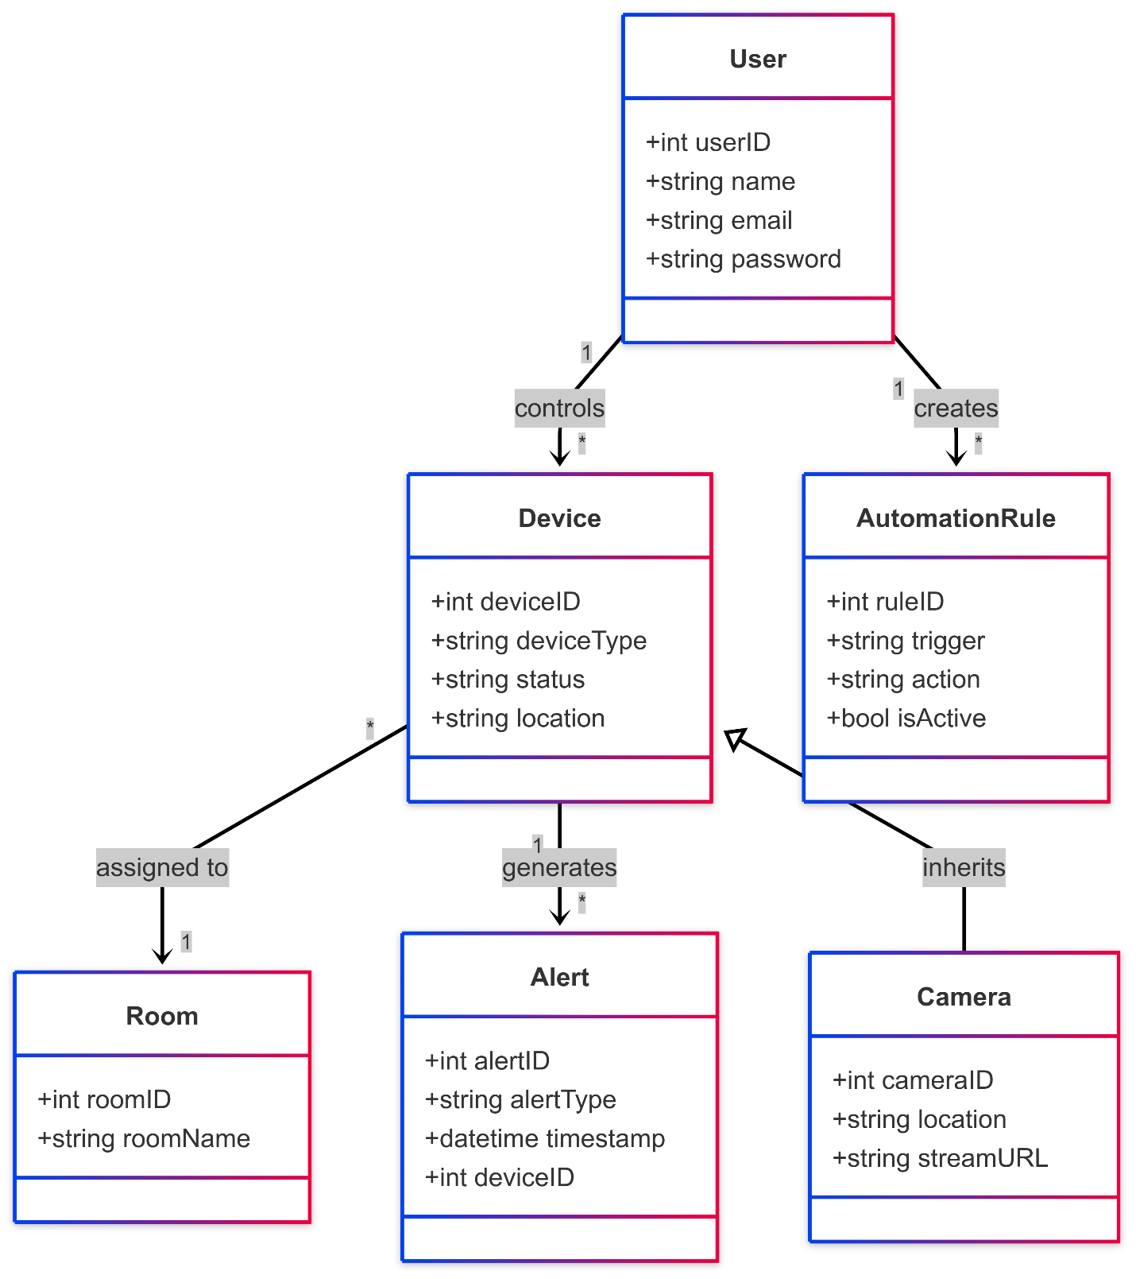

1. **UseCase Diagram:**

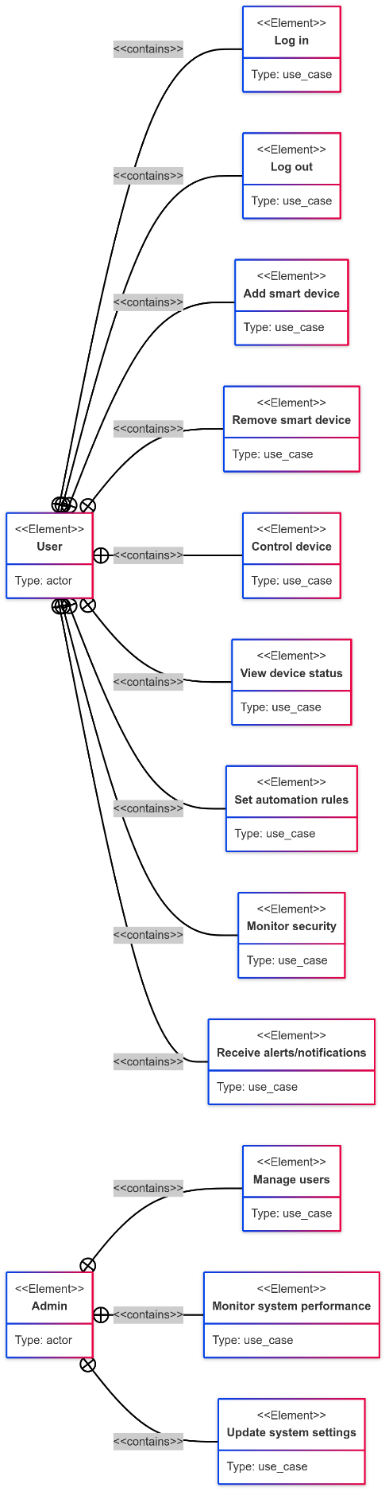

1. **Sequence Diagram:**

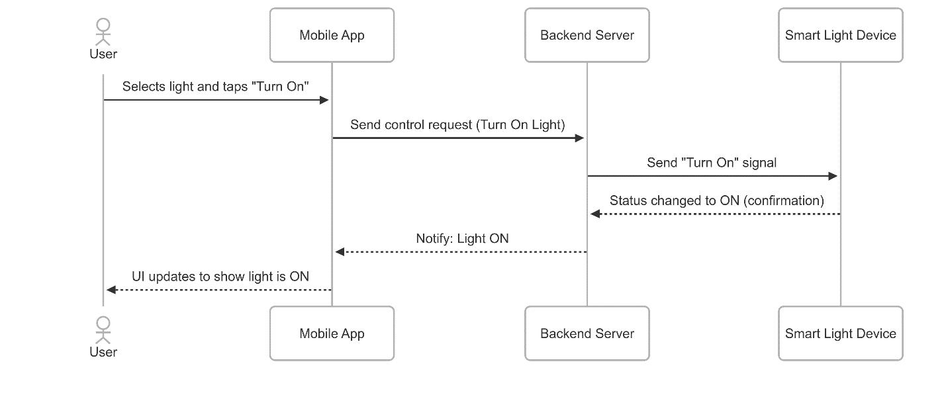

1. **ERD Diagram:**

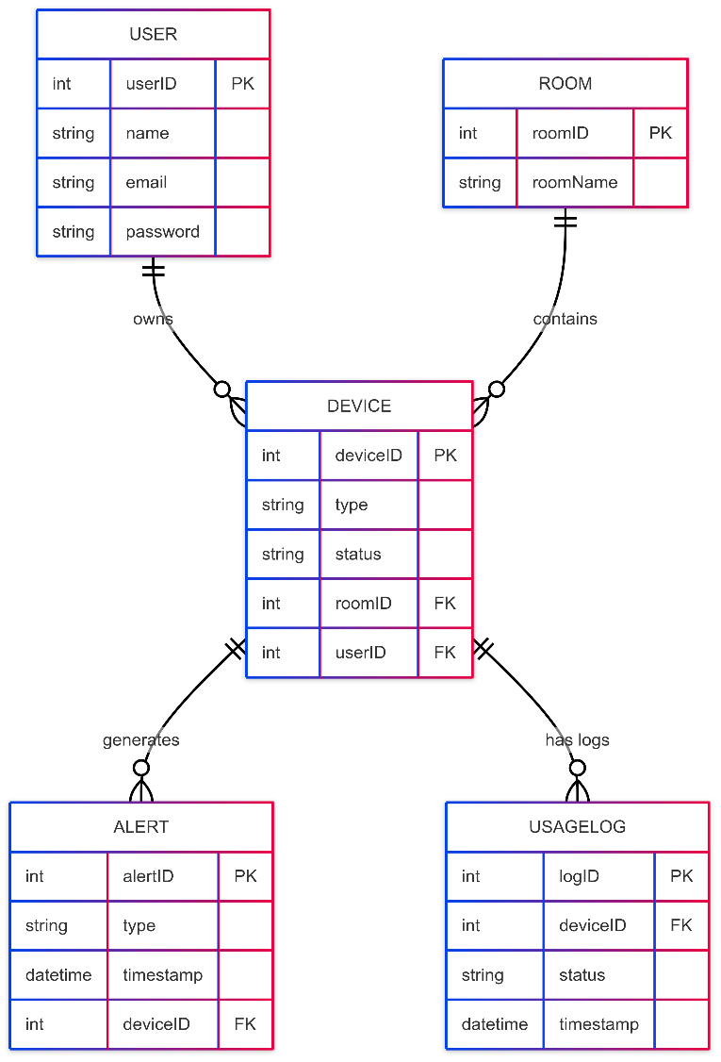

**6. Prototypes**

